C:\Users\traecit2\Desktop\excelsoft_logo.png

***LOAD BALANCER***



| Document Details | |
| --- | --- |
| Type Of Information | **Document Data** |
| Document Title |  |
| Document Reference Number |  |
| Document Owner |  |
| Security Classification |  |
| Review Frequency |  |

| Document Approval | | | |
| --- | --- | --- | --- |
| Name | **Role** | **Signature** | **Date** |
| Mahesh Jambardi | Chief Operating Officer | Mahesh Jambardi |  |
| Srinivas Chudamani | Sr. Manager IT & IS Infrastructure | Srinivas Chudamani |  |

| Version Control Details | | | |
| --- | --- | --- | --- |
| Version  Number | **Revision Date** | **Prepared by** | **Nature of Change** |
| 1.0 |  |  |  |
| 2.0 |  |  |  |
| 3.0 |  |  |  |
| 4.0 |  |  |  |
| 4.1 |  |  |  |
| 4.2 |  |  |  |
| 4.3 |  |  |  |
| 5.0 |  |  |  |

**Table of Contents**

[**1.**](#_heading=h.30j0zll)  **4**

[**2.**](#_heading=h.2et92p0)  **4**

[**2.1.**](#_heading=h.tyjcwt)

[**3.**](#_heading=h.lnxbz9)  **9**

[**3.1.** 9](#_heading=h.35nkun2)

[**4.**](#_heading=h.1y810tw) **REFERENCE 11**

**Steps:**

1. Log in to the Azure portal

* Navigate to Load Balancers
* In the Azure portal, search for "Load Balancer" in the search bar.
* Click on **"Load Balancers"** under the "Services" section

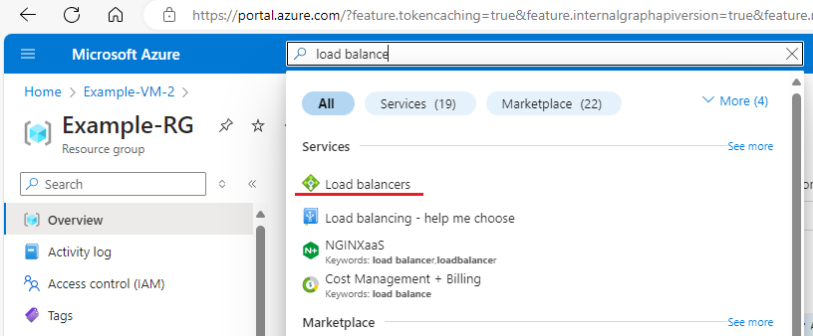

1. To Create a Load Balancer Click **"Create"**.

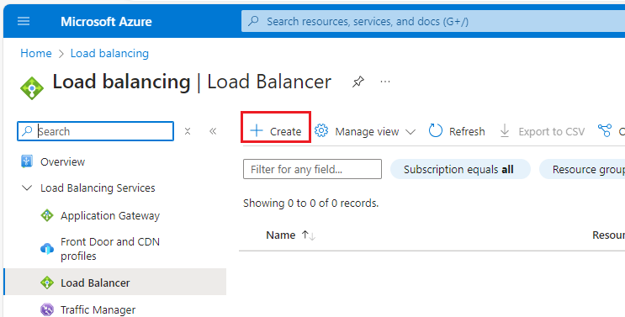

1. Fill out the required fields:

* Subscription: Select your subscription.
* Resource Group: Choose an existing resource group or create a new one.
* Name: Enter a name for the load balancer.
* Region: Choose the region where you want to deploy the load balancer.
* Select SKU : Standard, Type:Public, Tire: Regional

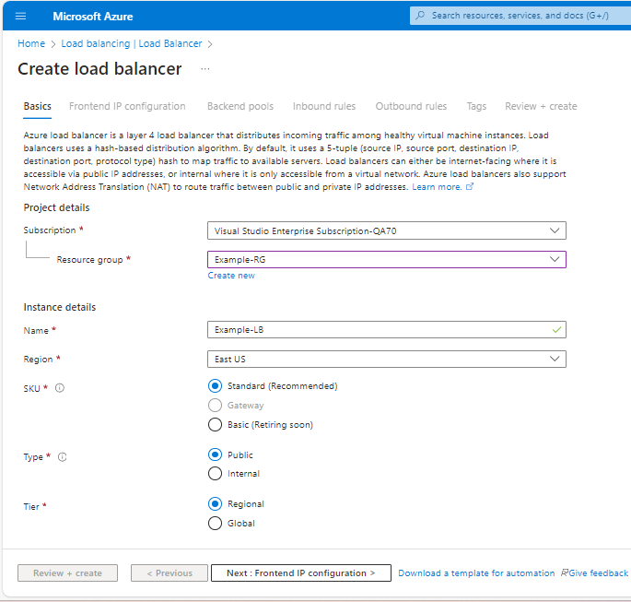

1. Configure Frontend IP

* For a **Public Load Balancer**:
* Under the "Frontend IP configuration" tab, click **"Add frontend IP configuration"**.
* Enter a name for the frontend IP configuration.
* Choose an existing public IP address or create a new one.Click on save
* Also save Add frontend IP configuration
* Click on next to add backed pool

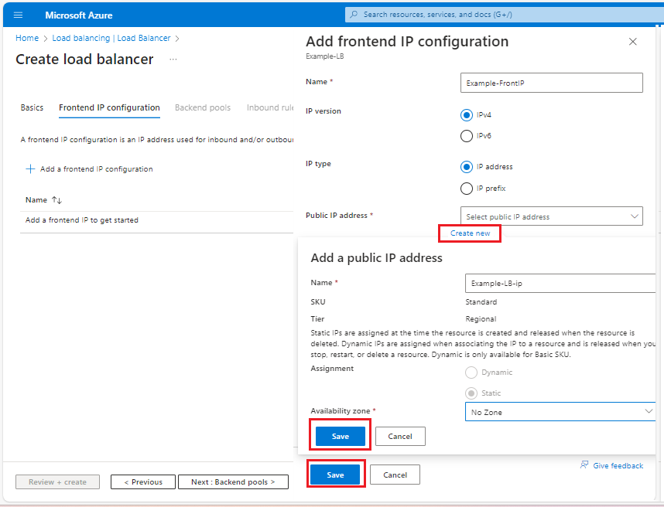

1. Configure Backend Pool

* Go to the "Backend pools" tab and click **"Add"**.
* Enter a name for the backend pool.
* Under "Associate with", select the virtual network where your VMs are located.
* Click **"Add"** to create the backend pool.

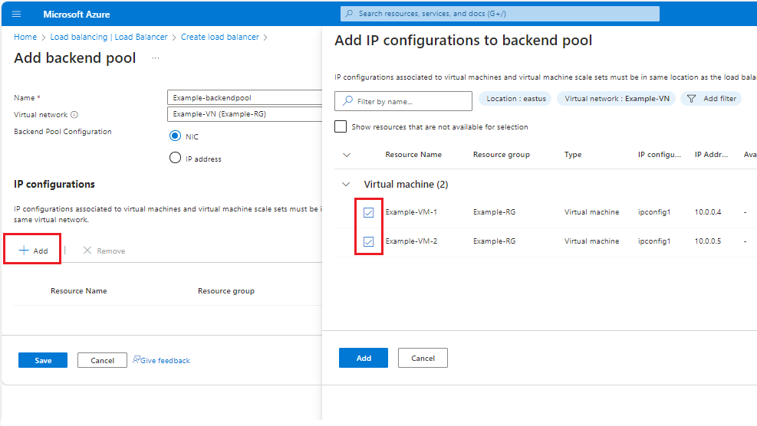

1. Configure Health Probes
   * Go to the "Health probes" tab and click **"Add"**.
   * Enter a name for the health probe.
   * Choose the protocol (TCP, HTTP, or HTTPS) and specify the port.
   * Configure additional settings as needed (interval, unhealthy threshold).
   * Click **"Add"**.
2. Configure Load Balancing Rules
   * Go to the "Load balancing rules" tab and click **"Add"**.
   * Enter a name for the rule.
   * Choose the frontend IP configuration you created earlier.
   * Choose the backend pool.
   * Select the protocol (TCP or UDP), and specify the frontend and backend ports.
   * Select the health probe you created earlier.
   * Configure other settings as needed.
   * Click **"Add"**.
3. Review and Create
   * Review your settings and click **"Create"** to deploy the load balancer.

2. Attach Existing VMs to the Load Balancer

1. Go to the Load Balancer
   * Navigate to the Load Balancer you just created in the Azure portal.
2. Configure the Backend Pool
   * Go to the "Backend pools" section.
   * Click on the backend pool you created.
   * Click **"Add"** under the "Targets" section.
   * Select the virtual machines you want to add to the backend pool.
   * Choose the NICs (Network Interface Cards) if applicable.
   * Click **"Add"**.
3. Verify Network Security Groups (NSGs)
   * Ensure that the Network Security Groups (NSGs) associated with your VMs allow traffic on the ports configured in your load balancing rules.
   * Adjust inbound security rules if necessary.
4. Verify VM Configuration
   * Make sure your VMs are configured to handle traffic on the ports specified in the load balancing rule.
5. Test the Load Balancer
   * Once everything is set up, test the load balancer by accessing the frontend IP address or DNS name.
   * Check if traffic is being distributed to the attached VMs as expected.

# 